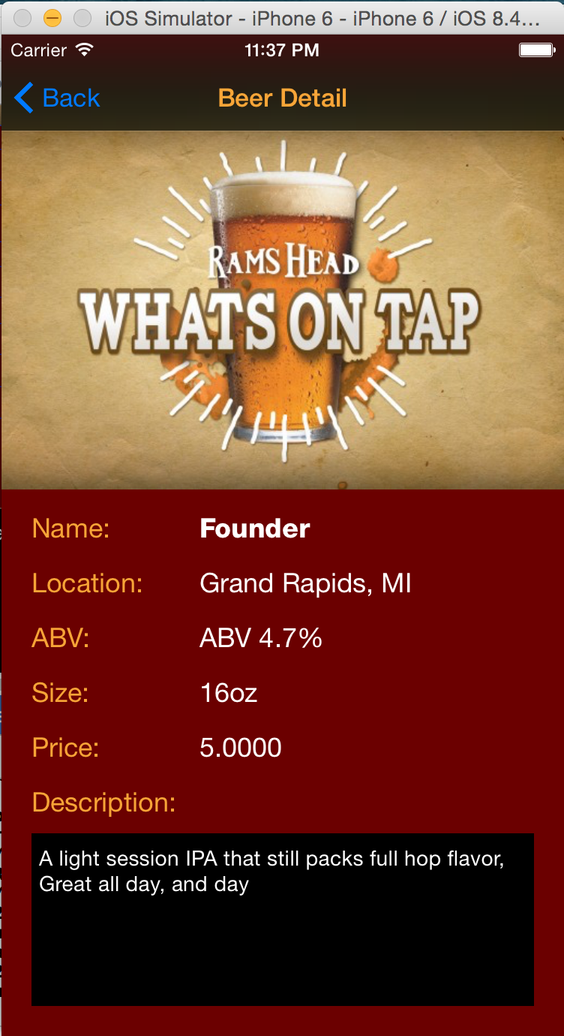**Beer Detail Page Design**

**Elements:**

Title: Beer Detail, orange

Navigation Buttom: “Back”, blue; back to last page(Beer List)

Image: under navigation bar, 300x247

Title labels:

orange, size 18

“Name:”, “Location:”, “ABV”, “Size:”, “Price:”, “Description:”

Beer info labels: white, size 18

“Name” is bold, others are regular

“Description” TextView:

black background, white text, font 17 regular